Technical Design

Spam Email Checker

Purpose
The purpose of this program is to check an email message and see if it could be spam. The program looks for common spam words and phrases. Each word or phrase found gives the email 1 point. The program then gives the email a spam score and tells the user how likely it is to be spam.
Input
The user will enter an email message into the program.
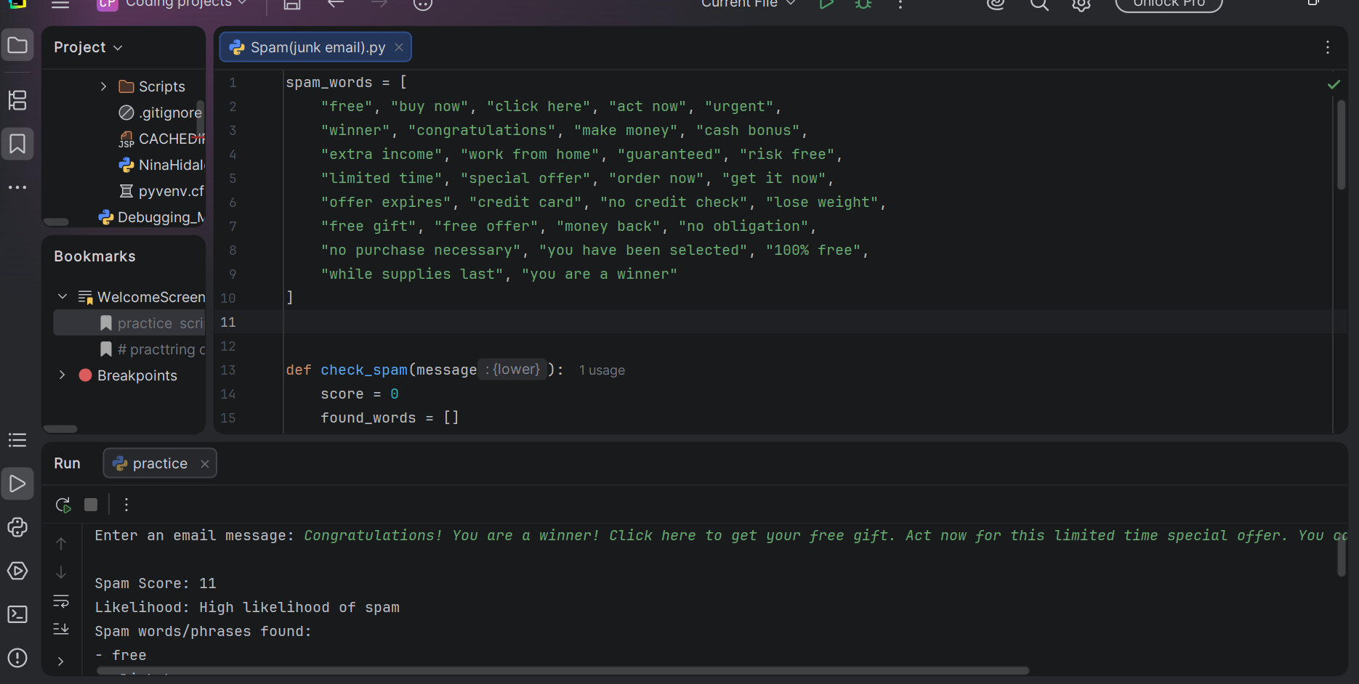

Output
The program will display:
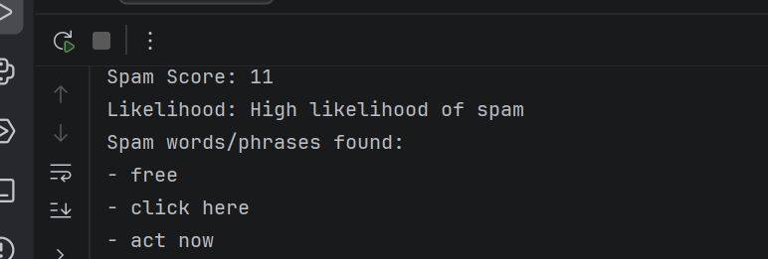

The spam score
How likely the message is to be spam
The spam words or phrases that were found
Spam Words and Phrases

The program will look for 30 common spam words and phrases:

1. free
2. buy now
3. click here
4. act now
5. urgent
6. winner
7. congratulations
8. make money
9. cash bonus
10. extra income
11. work from home
12. guaranteed
13. risk free
14. limited time
15. special offer
16. order now
17. get it now
18. offer expires
19. credit card
20. no credit check
21. lose weight
22. free gift
23. free offer
24. money back
25. no obligation
26. no purchase necessary
27. you have been selected
28. 100% free
29. while supplies last
30. you are a winner
How the Program Works
First, the user enters an email message. The program changes the message to lowercase so that capital letters do not affect the search. The program then goes through the list of spam words and phrases. If one is found in the email, the spam score goes up by 1 and the word or phrase is saved to be displayed later. The program uses the final score to decide the likelihood of spam:
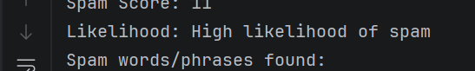
0–2 points = Low likelihood of spam
3–5 points = Possible spam
6 or more points = High likelihood of spam

Functions
check_spam(message)
This function checks the email for the spam words and phrases. It keeps track of the score and the words that were found.
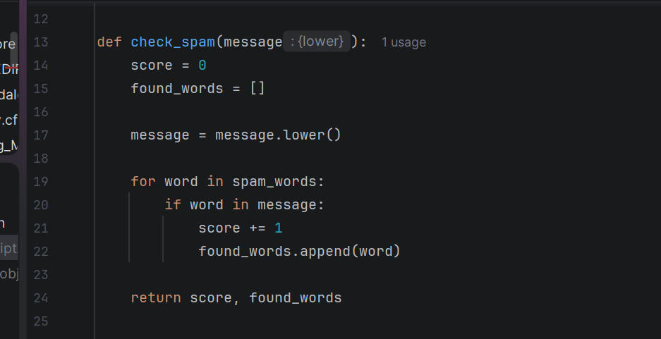

get_rating(score)
This function looks at the spam score and gives the message a rating.
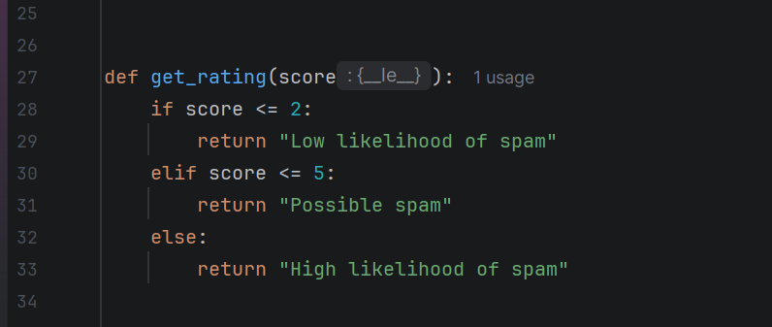

main()
This function gets the email message from the user and displays the results.

